EXPERIMENT-11 MID RANGE:
AIM:
To write the program for central tendency and data dispersion measures.
PROGRAM:
names&lt;-c(&quot;siri&quot;,&quot;mahi&quot;,&quot;chiru&quot;)
age&lt;-c(23,24,25)
marks&lt;-c(88,78,25)

df&lt;-data.frame(names,age,marks)
mid range(df $age)
write.csv(df,&quot;datafr.csv&quot;)
OUTPUT:
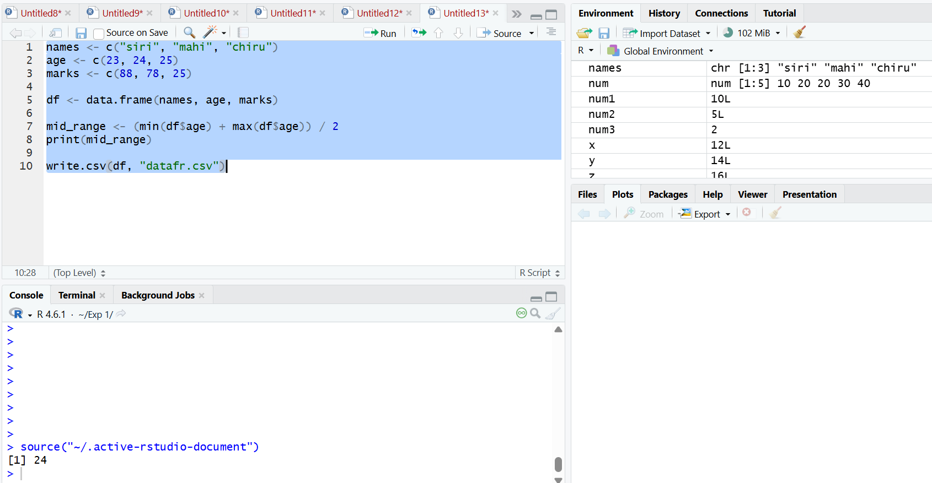

RESULT:
Thus, the program for central tendency and data dispersion measures was executed
successfully

